SOFTWARE DESIGN DOCUMENT
Krewe of Shamrock
Website & Membership Platform

Architecture, Wiring, Source Control, Hosting Options & Cost Analysis
Version 1.1 · June 10, 2026
Prepared for: Melissa Tully, Krewe of Shamrock
Repository: github.com/MissTully/Shamrock

Document Control
Version | Date | Author | Description
1.0 | 2026-06-10 | Krewe web project (Cowork) | Initial software design document
1.1 | 2026-06-10 | Krewe web project (Cowork) | Added GitHub repository, source-control & collaboration section, updated diagram, risks and roadmap

Contents

1. Executive Summary
This document describes the design of the Krewe of Shamrock website and its supporting services. The system is a modern, low-cost “static front-end + cloud backend” web application: a set of fast HTML pages served from a content-delivery network, with dynamic data (events, poetry and art, the online store, and member coordination tools) stored in a managed cloud database.
The site is live and publicly accessible, the source code is now version-controlled in a GitHub repository (github.com/MissTully/Shamrock) so it can be shared, cloned, and backed up, hosting is effectively free at today’s traffic, and the backend runs on a free database tier.
Headline recommendation: connect the GitHub repository to Vercel for automatic deploys, move the database to the Supabase Pro plan (about $25/month) so it never “pauses,” and add a custom domain. This delivers a reliable, professional presence for roughly $26/month — far less than the $120–$220/month an all-in-one membership platform would cost.

2. Purpose & Scope
This Software Design Document (SDD) is intended for the Krewe’s leadership and any volunteer or contractor who maintains the site. It covers:
- The overall architecture and the role of each component.
- The current wiring — exactly what is connected to what today.
- Source control and how to share, clone, and contribute to the code.
- Options for how to host and operate the site going forward.
- Current (2026) subscription costs and a side-by-side comparison of services.
- Risks in the present setup and recommended next steps.

3. System Overview
The website is built as a collection of static pages (plain HTML, CSS, and JavaScript). When a visitor opens a page, dynamic content is loaded directly in their browser from a managed cloud backend (Supabase) using a small JavaScript client. There is no traditional “web server” or custom server code to maintain — hosting just serves files, and the database service handles data.
Public pages include the Home page, Events, Parades & Safety, Tartan Ball, Join, Service & Charity, Gallery, Shop, Videos, Learn, and Poetry & Art. A passcode-gated Members area provides coordination tools (locker rentals, carpools, van pools, and a member directory).

4. Architecture
The diagram below shows the major components and how data flows between them. Source lives in GitHub; the live site is served by Vercel; the browser reads and writes the Supabase backend directly.
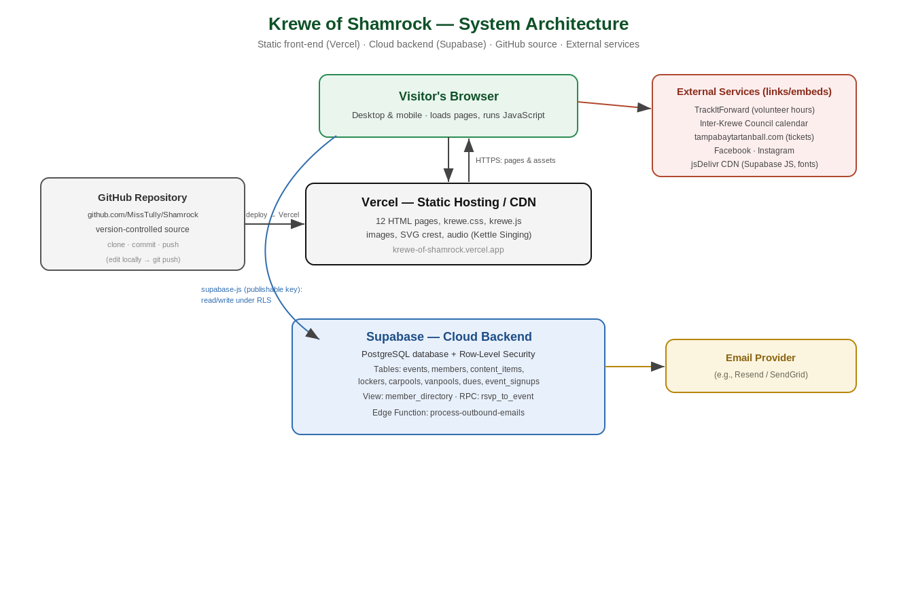

4.1 Components
Component | Role
Front-end (static site) | HTML/CSS/JavaScript pages, images, the SVG crest, and background audio. No server-side code.
Source control (GitHub) | The website code lives in github.com/MissTully/Shamrock — version history, backup, and sharing/cloning for collaborators.
Static host / CDN (Vercel) | Serves the files quickly worldwide over HTTPS. Currently krewe-of-shamrock.vercel.app.
Cloud backend (Supabase) | PostgreSQL database with Row-Level Security, plus auth, storage, and edge functions. The browser talks to it directly via a JavaScript client and a public “publishable” key.
Edge function (email queue) | A Supabase function (process-outbound-emails) designed to send transactional email via an email provider.
External services | Links/embeds to TrackItForward, the Inter-Krewe Council calendar, the Tartan Ball ticket site, and social media. The Supabase JS client and web fonts load from the jsDelivr CDN.

4.2 Key Data Flows
- Page load: the browser downloads HTML/CSS/JS and assets from the static host.
- Reading content: each dynamic page calls Supabase directly (events, poems, artwork, store, member tools) and renders the results.
- Submitting forms: RSVP, membership applications, locker/carpool/van-pool sign-ups write rows into Supabase tables.
- Publishing changes: code is committed to GitHub and deployed to Vercel.

5. Current Wiring

5.1 Front-End Pages
Twelve linked pages share one stylesheet (krewe.css) and one script (krewe.js, which powers the background music, scroll animations, and floating shamrocks). Pages: Home, Events (RSVP form), Parades & Safety, Tartan Ball, Join (membership application), Service & Charity, Gallery, Shop, Videos, Learn, Poetry & Art, and the gated Members area.

5.2 Backend Data Model
Data lives in a Supabase PostgreSQL database (project “Tribe Test”). The main tables and objects:
Table / object | Purpose
events / event_signups | Public events and the RSVPs/volunteer sign-ups made against them.
members | The Krewe roster (name, contact, role, status).
dues_payments / dues_reminders | Membership dues owed/paid and the reminder history.
content_items | All managed site content: gallery images, videos, lessons, poems, and Celtic art.
lockers | Member locker-rental requests and assignments.
carpools | Ride offers and ride requests.
vanpools / vanpool_reservations | Krewe vans and seat reservations.
member_directory (view) | A safe, names-and-roles-only view of active members (no contact details exposed).
outbound_emails | A queue of emails for the edge function to send.
rsvp_to_event (function) | Server-side routine that records an RSVP and handles capacity/waitlist.
Security model: Row-Level Security is enabled on these tables. The site uses a public “publishable” key, so any data the public role can read is effectively public. Sensitive columns (member emails/phones) are deliberately kept out of the public directory view.

5.3 Authentication & Access Control
The Members area is protected by a single shared passcode checked in the browser (currently “2026”). This is a light deterrent, not true security: because the page and its data key are public, a determined person could reach the underlying data. Per-member login (Supabase Auth) would be required for genuine privacy and is noted as a future option.

5.4 External Integrations
Service | How it is used
TrackItForward | Linked from the Service page for logging volunteer hours.
Inter-Krewe Council calendar | Embedded as an image card on the Events page, linking to interkrewe.com.
tampabaytartanball.com | Linked from the Tartan Ball page for ticketing.
Facebook / Instagram | Linked in page footers.
jsDelivr CDN / Google Fonts | Delivers the Supabase JavaScript client and web fonts.

5.5 Hosting & Deployment (Current)
- Live URL: krewe-of-shamrock.vercel.app (Vercel, “encountive” account).
- Source code: github.com/MissTully/Shamrock (version-controlled).
- Deployment is currently a manual step (Vercel CLI); connecting the GitHub repo to Vercel would make deploys automatic on every push.
- The backend currently shares an existing Supabase project (“Tribe Test”); a dedicated project was deferred due to an unrelated billing hold.

6. Source Control & Collaboration (GitHub)
The website’s source code is stored in a GitHub repository so it can be shared, cloned to any computer, backed up off-site, and edited collaboratively with a full history of changes.
Item | Detail
Repository | github.com/MissTully/Shamrock
Clone URL (HTTPS) | https://github.com/MissTully/Shamrock.git
Owner | MissTully
Tracked | All site files: HTML pages, krewe.css, krewe.js, images, the SVG crest, audio.
Not tracked (.gitignore) | Large raw uploads (zip archives, source videos), local Vercel link, and OS temp files — kept out to keep the repo lean.
Not in the repo | No secrets. Only the public Supabase “publishable” key ships in the code; private service keys live in Supabase, not GitHub.

6.1 Cloning the Repository
Anyone can download a full copy (“clone”) of the site. With Git installed, in a terminal:
git clone https://github.com/MissTully/Shamrock.git
Prefer no terminal? Use GitHub Desktop: File → Clone Repository → paste the URL. Then open the folder and double-click index.html to preview the site locally.

6.2 Everyday Workflow
To pull the latest, make a change, and publish it back to GitHub:
git pull # get the latest version
# ...edit the files... # make your changes
git add .
git commit -m "Describe the change"
git push # send it to GitHub
In GitHub Desktop the same steps are: Fetch/Pull, then type a summary and click Commit, then Push.

6.3 Sharing & Access
- Viewing/cloning: share the repository URL. If the repo is public, anyone can view and clone it; only collaborators can push changes.
- Granting edit access: on GitHub, open the repo → Settings → Collaborators → add a person by GitHub username or email. They receive an invite and can then push.
- If the repo is private: only invited collaborators can see or clone it — sharing the link alone is not enough; send a collaborator invite.

6.4 Automatic Deploys (recommended)
Connect the repository to Vercel so every push to the main branch redeploys the live site automatically — removing the manual deploy step:
- In Vercel: Add New → Project → Import Git Repository → choose MissTully/Shamrock → Deploy.
- After this, editing and pushing to GitHub is all that’s needed; the live site updates within seconds.

7. Setup & Hosting Options
There are three sensible ways to run the Krewe’s web presence. All three keep the current pages; they differ in where things are hosted and how much is managed for you.

Option A — Static host + Supabase (current approach)
Keep the static site on a CDN host (Vercel, Cloudflare Pages, or Netlify), deployed from GitHub, with the Supabase backend. Lowest cost, fast, full control; requires a volunteer comfortable with the GitHub workflow and basic database edits.

Option B — All-in-one membership platform (e.g., Wild Apricot)
Move to a hosted membership platform that bundles website, member database, dues, events, and email in one subscription (this is the Krewe’s previous platform). Easiest to administer with no technical skills, but the most expensive and least flexible in design.

Option C — Hybrid
Keep the custom marketing site (Option A) for public pages and brand, and use a membership platform or simple tools only for the member database/dues. Balances polish with administrative ease, at moderate cost and some duplication.

7.1 Option Comparison
Factor | A: Static + Supabase | B: All-in-one | C: Hybrid
Monthly cost | $0–$26 | $120–$220 | $60–$150
Ease of admin | Moderate | Easiest | Moderate
Design control | Full | Limited | Full (public site)
Technical skill | Some needed | None | Some needed
Best for | Lowest cost, custom look | Hands-off, non-technical | Polish + easy dues

8. Cost Analysis & Subscription Comparison
All figures are 2026 list prices in US dollars and are subject to change; see the References section for sources. “MAU” means monthly active users.

8.1 Current Monthly Cost
Today the Krewe pays effectively $0/month: the site is on Vercel’s free Hobby tier and the database is on Supabase’s free tier. Two caveats apply (see Risks): Vercel’s Hobby tier is intended for non-commercial use, and Supabase’s free tier pauses a project after about one week of inactivity, which would temporarily break dynamic content.

8.2 Static Hosting Providers
Provider | Free tier | Paid | Notes
Cloudflare Pages | Yes — unlimited bandwidth | $5/mo | Best free value for static sites; no bandwidth/egress fees.
Vercel (current) | Yes — 100 GB/mo | $20/dev/mo | Free tier is non-commercial; Pro adds 1 TB and commercial use.
Netlify | Yes — credit-based | ~$20/mo | Flat paid rate includes unlimited team members.
GitHub Pages | Yes | Free | Simple static hosting straight from the repo; no edge functions.

8.3 Backend / Database (Supabase)
Plan | Price | What you get
Free | $0 | 500 MB database, 50k MAU, 2 projects. Pauses after ~7 days inactivity; no daily backups.
Pro | $25/mo | 8 GB database, no pausing, daily backups, email support, $10 compute credit. Recommended.
Team | $599/mo | Compliance, longer backup retention, priority support. Not needed for the Krewe.

8.4 Transactional Email (for automated messages)
Provider | Price | Notes
Resend | Free / $20/mo | 3,000 emails/mo free (100/day); $20/mo for 50,000. Simple; recommended.
SendGrid | ~$19.95/mo | Free plan discontinued in 2025; 60-day trial only.

8.5 All-in-One Membership Platform (Wild Apricot)
Priced by number of contacts. With roughly 140 members plus prospects and past contacts, the Krewe would land in the Community or Professional tier. Annual billing saves about 10%.
Tier (contacts) | Price/mo | Fit for the Krewe
Personal (100) | $60 | Too small for the full contact list.
Group (250) | $80 | Possible if contacts stay under 250.
Community (500) | $120 | Likely tier; comfortable headroom.
Professional (2,000) | $220 | Only if the contact list grows substantially.

8.6 Recommended Configurations
Configuration | Approx./mo | Summary
Lean (free) | ~$0 | Cloudflare Pages or Vercel Hobby + Supabase Free + Resend Free. Lowest cost, but accept the free-tier pausing risk and add a wake-up safeguard.
Recommended | ~$26 | GitHub → host + Supabase Pro ($25) + Resend Free + domain (~$1.25/mo amortized). Reliable, always-on, with backups and auto-deploys.
All-in-one | $120–$220 | Wild Apricot. Hands-off administration; highest cost; less design control.
Custom domain: a .com typically costs about $12–$20 per year (≈ $1–$2/month) from a registrar; it can point at any of the static hosts above.

9. Risks & Considerations
Risk | Impact | Mitigation
Supabase free tier pauses after ~1 week idle | Events, poems, art, store, and member tools stop loading until reactivated | Move to Supabase Pro ($25/mo), or schedule a periodic ping to keep it awake
Shared “Tribe Test” project / billing hold | Krewe data mixed with another project; limited control | Resolve the billing hold and migrate to a dedicated Krewe project
Client-side passcode (Members area) | Not true security; data key is public | Add per-member login (Supabase Auth) if real privacy is required
Manual deploys (until Git is connected) | Edits don’t go live until a manual deploy is run | Connect the GitHub repo to Vercel for automatic deploys on push (Section 6.4)
Vercel Hobby is non-commercial | Possible terms mismatch for an org site | Use Cloudflare Pages (free, commercial-OK) or Vercel Pro
Resolved since v1.0: the source is now in a GitHub repository, providing version history and an off-site backup of the code.

10. Recommendations & Roadmap
- Done — source is version-controlled in GitHub (github.com/MissTully/Shamrock); keep committing changes there.
- Connect the GitHub repository to Vercel for automatic deploys (removes the manual step).
- Adopt the Recommended configuration (~$26/month): Supabase Pro + a custom domain.
- Migrate to a dedicated Supabase project once the billing hold is resolved.
- Add a custom domain (e.g., kreweofshamrock.com) and point it at the host.
- If genuine member privacy is needed, add per-member login; otherwise keep the simple passcode.
- Optionally consolidate the 12-item navigation into grouped menus for easier mobile use.

Appendix A — Glossary
Term | Meaning
Static site | Pre-built HTML/CSS/JS files served as-is; no server-side processing.
CDN | Content Delivery Network — servers worldwide that deliver files quickly.
Repository (repo) | A version-controlled store of the project’s files and history (here, on GitHub).
Clone | Download a full copy of a repository to your computer.
Commit / push | Save a change to history (commit) and upload it to GitHub (push).
Supabase | A managed cloud platform providing a PostgreSQL database, auth, storage, and functions.
Row-Level Security (RLS) | Database rules controlling which rows each user/role may read or write.
Edge function | Small server-side code that runs on demand (here, to send queued emails).
Publishable key | A public API key safe to ship in the browser; access is still governed by RLS.

Appendix B — References (2026 pricing sources)
Krewe of Shamrock repository (GitHub)
Vercel pricing
Supabase pricing
Cloudflare Pages / Netlify comparison
Resend pricing
Wild Apricot pricing

